See we need to find the smaller element just next to the element.

This example with solution given.

Logic on this.

See we will take stack and put the element from index 0 into the stack and then we will iterate from 1 to n-1 .

We will also take x where we will put 8 in it and check if this is smaller than 4 no. hence put 8 in stack.

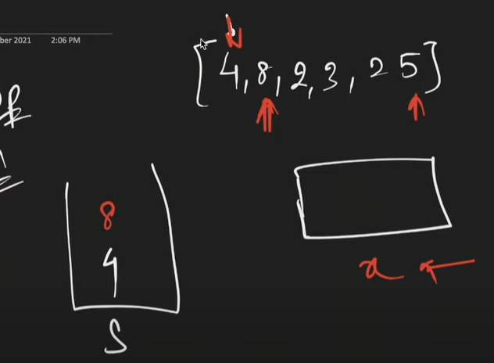

See now put 2 in x.is 2 less than 4 yes. The we know 8 answer is 2.

Remove 8 from stack. Then check if 2 is smaller than 4 yes hence 4 ans is also 2.

Now see stack empty and hence don’t check just put 2 in stack. Go for 3 is 3 smaller than 2 not hence just put 3 in stack.25 the same not smaller than 3.see here stack is end. Hence remaining is -1.

Here normally n but worst condition that is ascending order tc will be 2n.

Code:

See what happening here is 4 8 consider this 4 8 will be increasing order means when checking for 8 and 6 that 6 less than 8 then it means there 4 8 not between less than 6.meaning till less than comes the element in stack pop will be in decreasing order. And consider 8 out then in stack will be 6 4 which is still decreasing order.